# OpenEuler RISC-V

## 1、使用ubuntu20.04，更换国内源并更新系统

sudo apt install vim  
sudo cp /etc/apt/sources.list /etc/apt/sources.list.bak  
sudo vim /etc/apt/sources.list

按“Ins”键，清除所有内容，并复制以下内容：

deb http://mirrors.aliyun.com/ubuntu/ focal main restricted universe multiverse  
deb-src http://mirrors.aliyun.com/ubuntu/ focal main restricted universe multiverse  
  
deb http://mirrors.aliyun.com/ubuntu/ focal-security main restricted universe multiverse  
deb-src http://mirrors.aliyun.com/ubuntu/ focal-security main restricted universe multiverse  
  
deb http://mirrors.aliyun.com/ubuntu/ focal-updates main restricted universe multiverse  
deb-src http://mirrors.aliyun.com/ubuntu/ focal-updates main restricted universe multiverse  
  
deb http://mirrors.aliyun.com/ubuntu/ focal-proposed main restricted universe multiverse  
deb-src http://mirrors.aliyun.com/ubuntu/ focal-proposed main restricted universe multiverse  
  
deb http://mirrors.aliyun.com/ubuntu/ focal-backports main restricted universe multiverse  
deb-src http://mirrors.aliyun.com/ubuntu/ focal-backports main restricted universe multiverse

按下“Esc”键，而后输入“:wq”,而后回车键

sudo apt update  
sudo apt upgrade

## 2、下载qemu，并编译安装

mkdir ~/openEuler/RISC-V
  
cd ~/openEuler/RISC-V
  
wget https://download.qemu.org/qemu-7.0.0.tar.xz
  
tar xnJf qemu-7.0.0.tar.xz
  
cd qemu-7.0.0
  
sudo apt-get install build-essential zlib1g-dev pkg-config libglib2.0-dev binutils-dev libboost-all-dev autoconf libtool libssl-dev libpixman-1-dev libpython-dev python-pip python-capstone virtualenv
  
sudo apt install make
  
sudo apt install ninja-build
  
sudo apt install gcc
  
sudo apt install libglib2.0-dev
  
sudo apt install libpixman-1-dev
  
./configure --target-list=riscv64-softmmu,riscv64-linux-user --prefix=/home/XXX/openEuler/RISC-V/program/riscv64-qemu

"XXX"根据自己设置的用户名决定

make  
make install  
vim ~/.bashrc

按“Ins”键，在文件末尾，并复制以下内容：

export QEMU_HOME=/home/XXX/openEuler/RISC-V/program/riscv64-qemu  
export PATH=$QEMU_HOME/bin:$PATH

按下“Esc”键，而后输入“:wq”,而后回车键

source ~/.bashrc
  
echo $PATH

此时应该输出

/home/XXX/openEuler/RISC-V/program/riscv64-qemu/bin:/usr/local/sbin:/usr/local/bin:/usr/sbin:/usr/bin:/sbin:/bin:/usr/games:/usr/local/games:/snap/bin

"XXX"根据自己设置的用户名决定

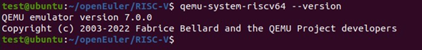

验证安装是否正确

qemu-system-riscv64 --version

此时应该输出

QEMU emulator version 7.0.0  
Copyright (c) 2003-2022 Fabrice Bellard and the QEMU Project developers

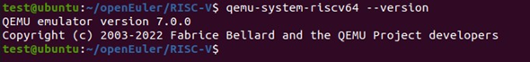

## 3、下载OpenEuler RISC- V镜像

cd ../  
wget https://repo.openeuler.org/openEuler-preview/RISC-V/Image/openEuler-preview.riscv64.qcow2  
git clone https://gitee.com/yunxiangluo/riscv-openeuler.git  
vim run.sh

按“Ins”键，复制以下内容：

qemu-system-riscv64 \  
 -nographic -machine virt \  
 -smp 8 -m 4G \  
 -kernel fw_payload_oe.elf \  
 -drive file=openEuler-preview.riscv64.qcow2,format=qcow2,id=hd0 \  
 -object rng-random,filename=/dev/urandom,id=rng0 \  
 -device virtio-rng-device,rng=rng0 \  
 -device virtio-blk-device,drive=hd0 \  
 -device virtio-net-device,netdev=usernet \  
 -netdev user,id=usernet,hostfwd=tcp::12055-:22 \  
 -append 'root=/dev/vda1 rw console=ttyS0 systemd.default_timeout_start_sec=600 selinux=0 highres=off mem=4096M earlycon' \  
 -bios none

## 4、运行测试OpenEuler RISC-V

chmod +x run.sh  
./run.sh

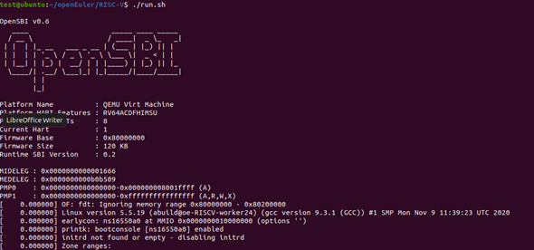

登录用户名：root

默认密码：openEuler12#$

## 5、安装运行测试neofetch

在ubuntu20.04系统中：

git clone https://github.com/dylanaraps/neofetch  
scp -P 12055 -r neofetch/ root@127.0.0.1:./  
ssh root@127.0.0.1 -p 12055

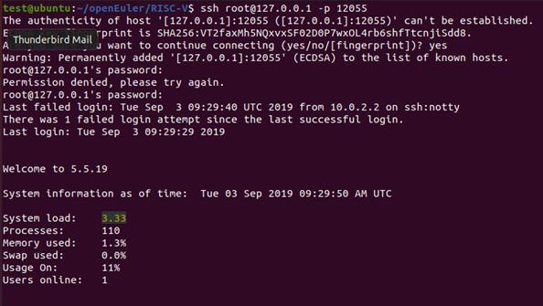

输入用户名：root

口令：openEuler12#$

cd neofetch/  
 make install  
 neofetch

输出如图：

